71. HTTP Request Methods and Connect 2 ORGS - 15 July 2022

Today we will learn:

1] Types of API

2] HTTP Request Method

3] Connect 2 Orgs

1] Types of API

* REST API
* SOAP API

REST API : **Representational State Transfer**

**SOAP API : Simple Object Access Protocol**

2] HTTP Request Methods

GET 🡪 Used **to simply get the data from the target/destination**.

POST 🡪 Used to create the data at the Target .

PUT 🡪 Used to Update the data at the Target.

PATCH 🡪 Used to partially update the data at the Target.



DELETE 🡪 Used to Delete the data at the Target.



|  |  |
| --- | --- |
| **Source ORG** | **Target ORG** |
|  |  |



PUT VS PATCH = https://www.youtube.com/watch?v=f6TsImXa6Ew

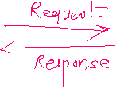

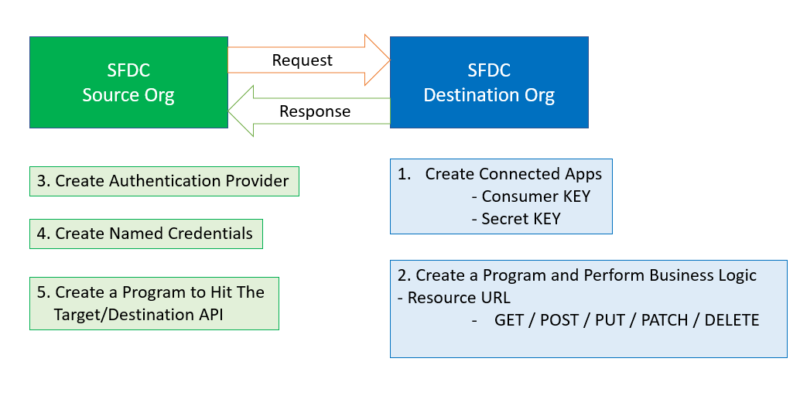



1] Create Connect Apps

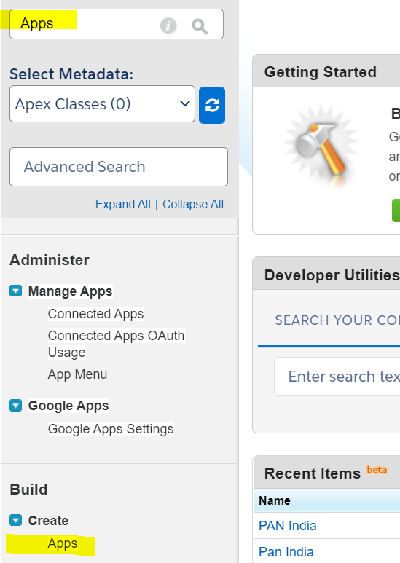

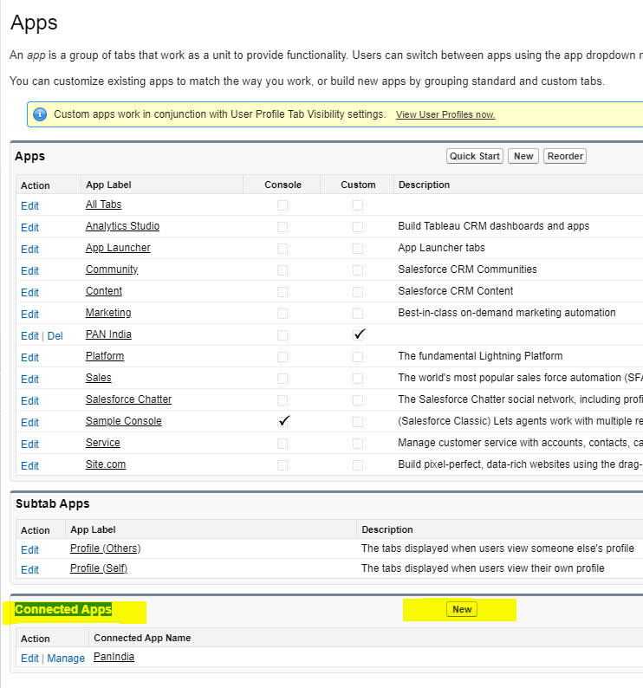

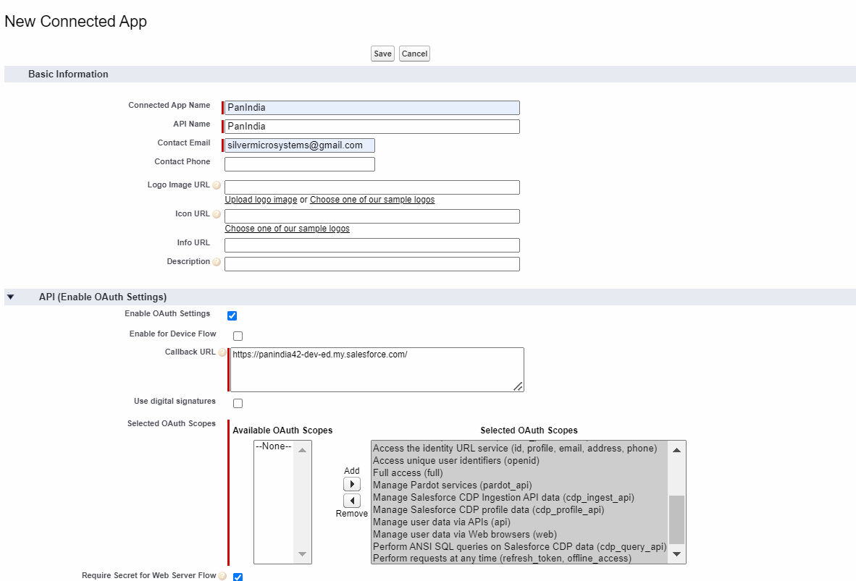

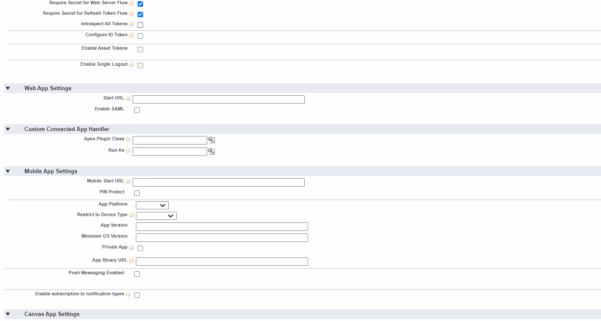

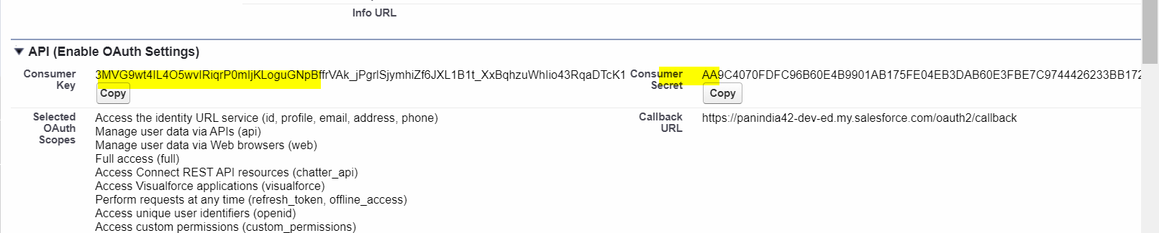

2] Target Org

@RestResource(urlMapping='/getAccountDetails')

global class AccountProvider {

@httpGet

global static List<Account> fetchAllAccounts(){

return [select Id, Name, Type, Rating from Account LIMIT 5];

}

}

=================================================================

Source ORG

3] Create Auth Providers

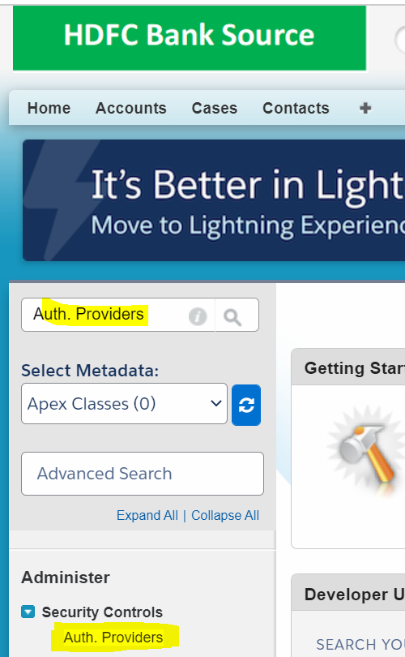

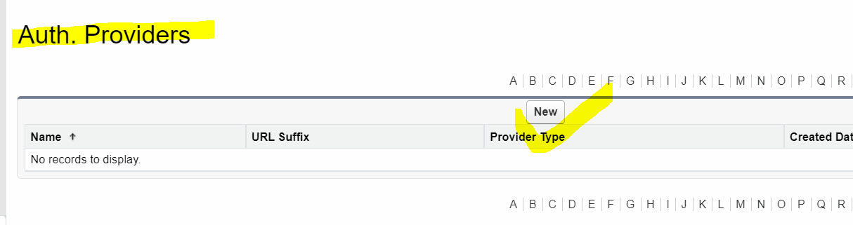

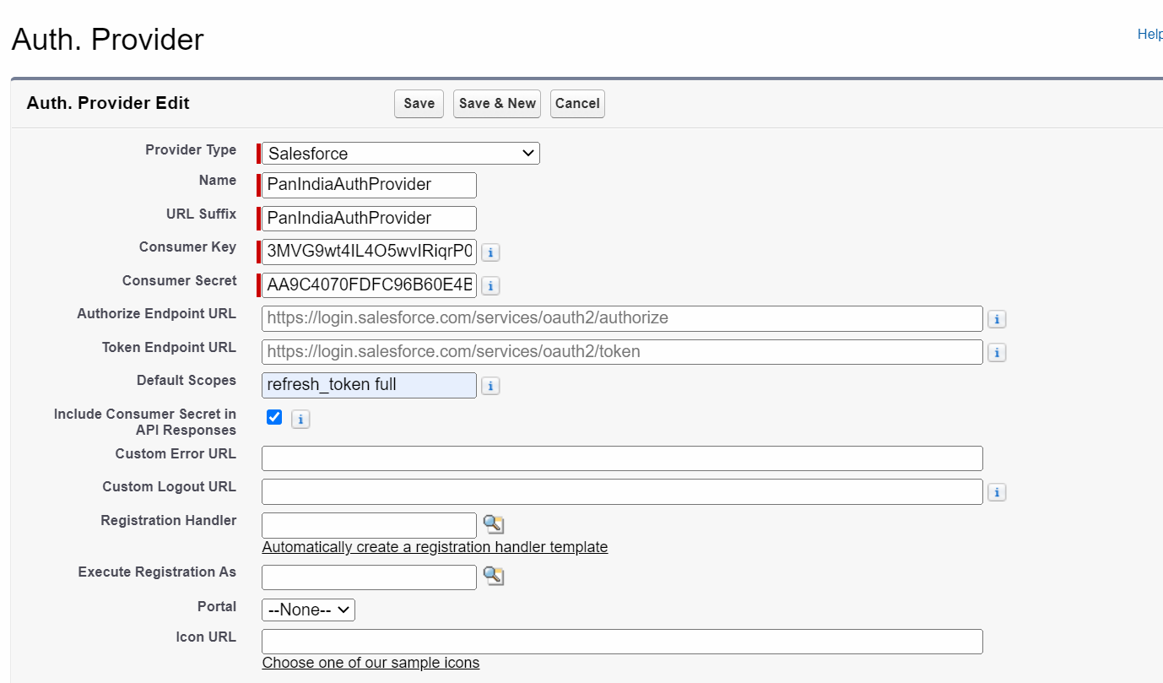



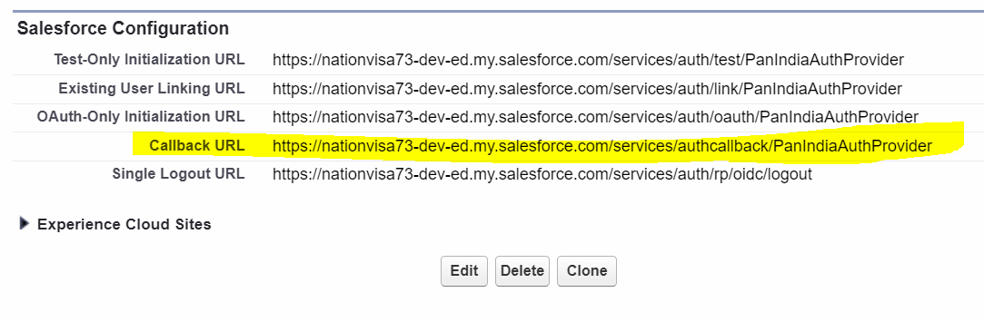

4] Create Named Credentials

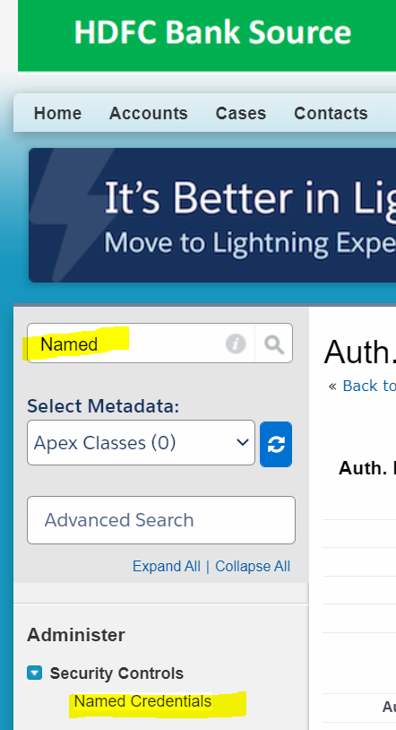

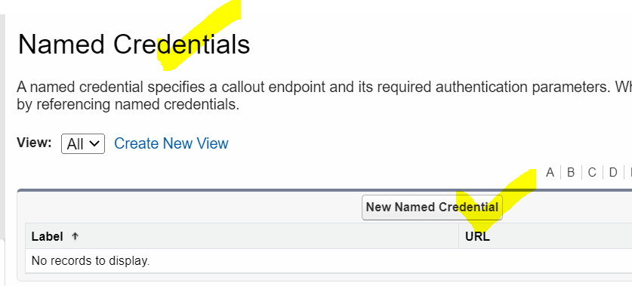

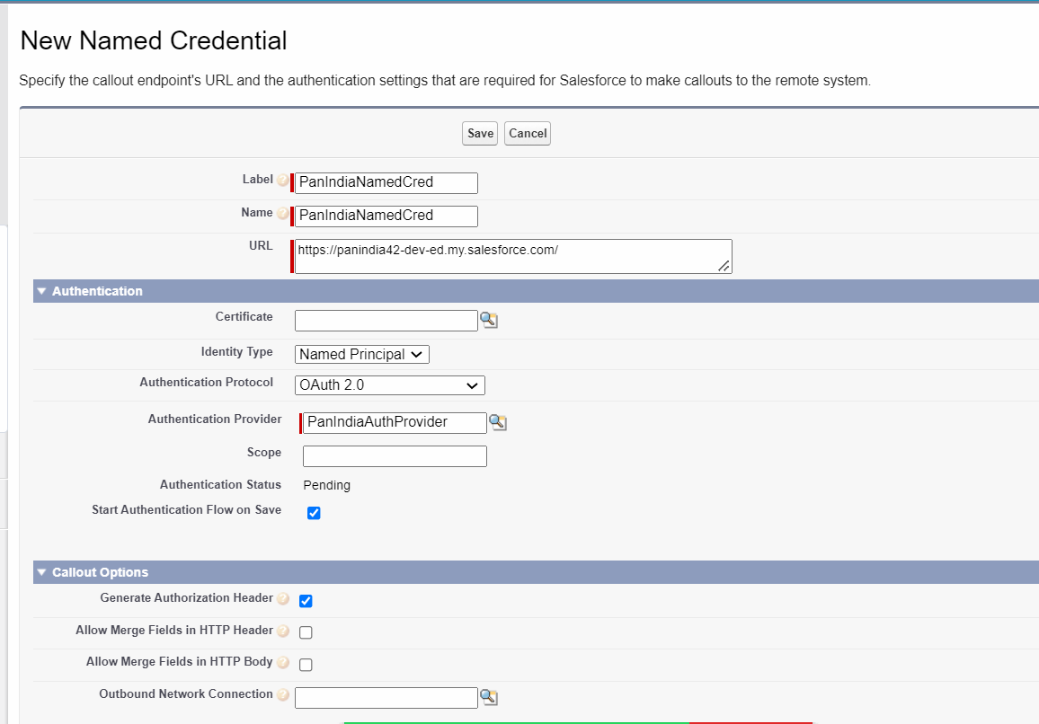



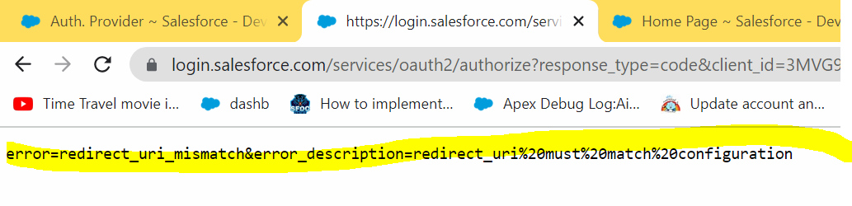

Resolution:

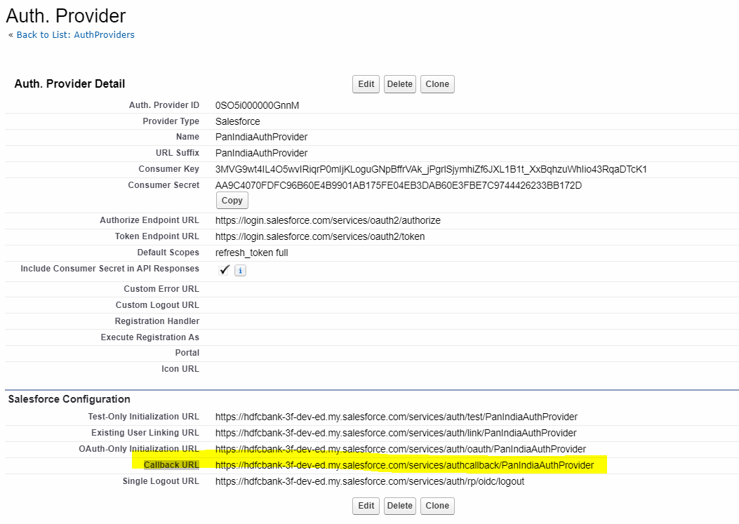

Target Org : Connect Org

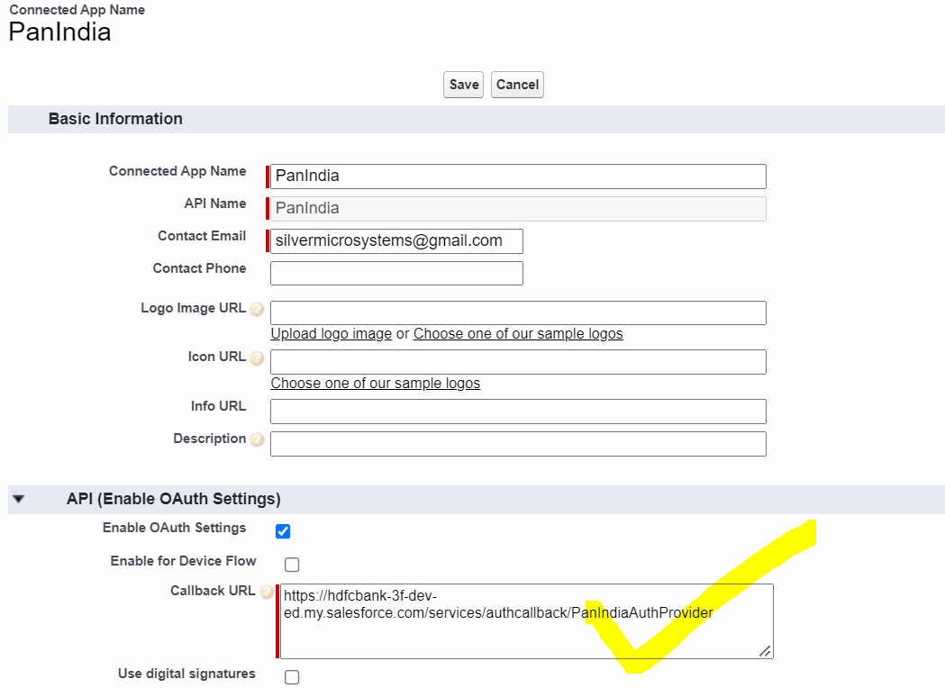



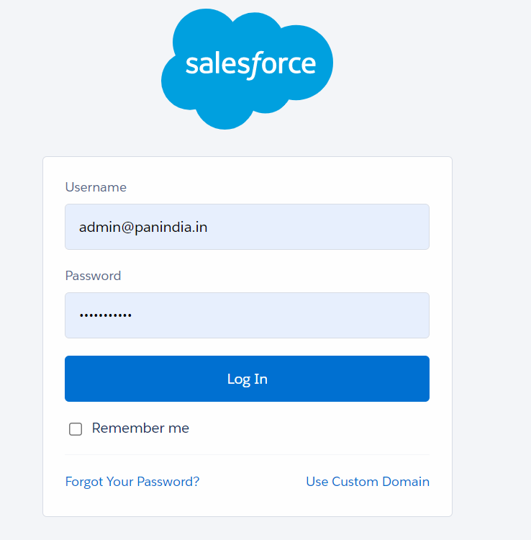



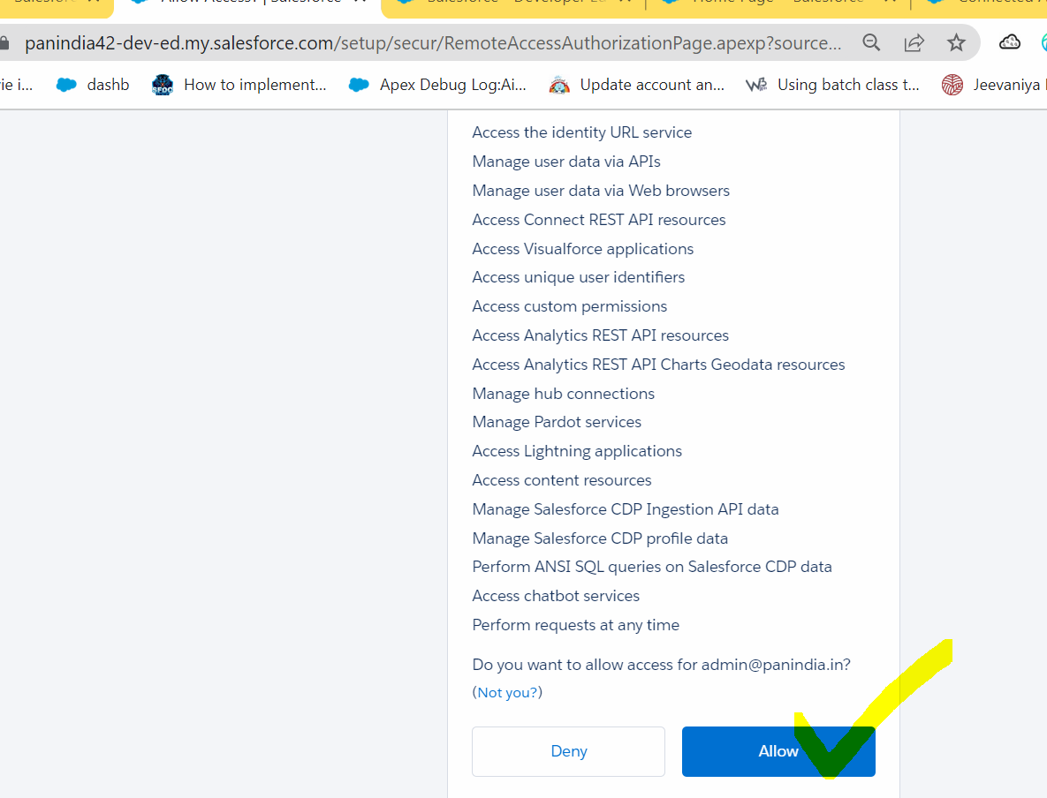

POSTMAN:

Target API URL : https://panindia-2d-dev-ed.my.salesforce.com/services/apexrest/getAccountDetails



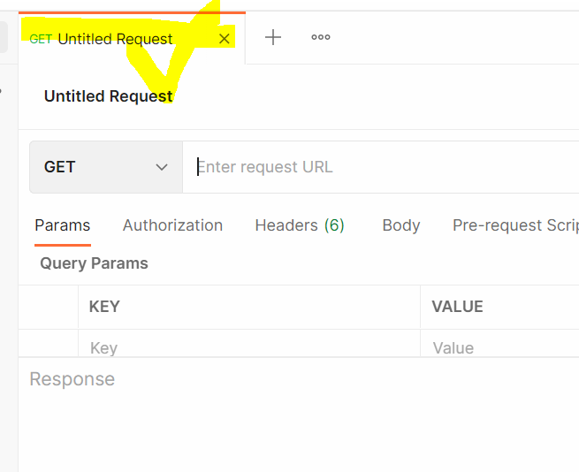

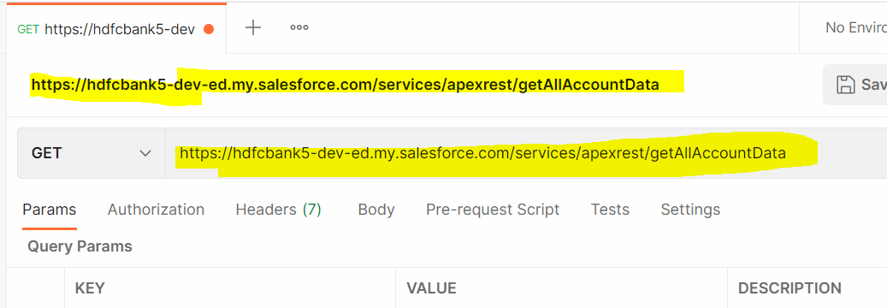

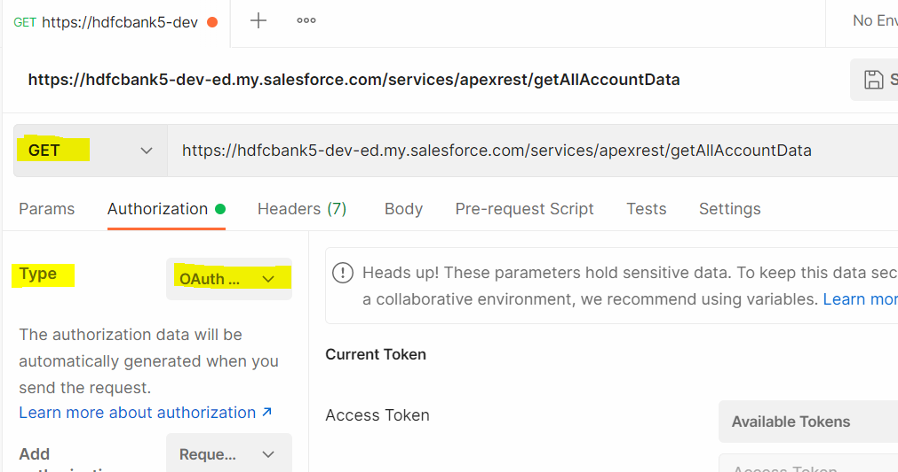



SOURCE Wala

Auth URL : https://nationvisa73-dev-ed.my.salesforce.com/**services/oauth2/authorize**

Access Token URL : https://nationvisa73-dev-ed.my.salesforce.com/**services/oauth2/token**

